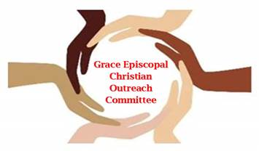
Report Form for 2023 grants– Due January 8, 2024
Date:
Organization Name:
Grant Amount:

- Approximately how many individuals were served by the grant in the past year?

individuals _________ families__________ other_____________

- What geographical area(s) did your mission serve? Circle all that apply:

Rockbridge Co. Lexington Buena Vista Other ___________________

- How did your organization support racial equity in our community in 2023?

- What was the ethnic distribution of the population this program served in 2023?

- Has your mission changed since being awarded the grant? Yes No If yes, please explain changes.
- Did your plan for the grant meet its objectives? Yes No If no, please explain.
- Did Grace Episcopal Church volunteers serve your organization in the past year? Yes No
If yes, please describe their role(s).
- Please attach a brief breakdown of how the grant funds were used.

Name_______________________________ Signature_______________________________

Position in the organization_______________________________________________________

Email_________________________________ Phone__________________________________

Applications for 2024 grant funding will be due January 7, 2024. The application form can be completed at http://www.graceepiscopallexington.org/outreach.html and emailed to outreach@graceepiscopallexington.org.

